Hebrew Calendar
# Source: AI Source: Provided by: [Data Path: Persons Table -> ID Column: 1, Name_En Column: Motasem Essam] -> From: [ChatGPT] on [7/17/2026]
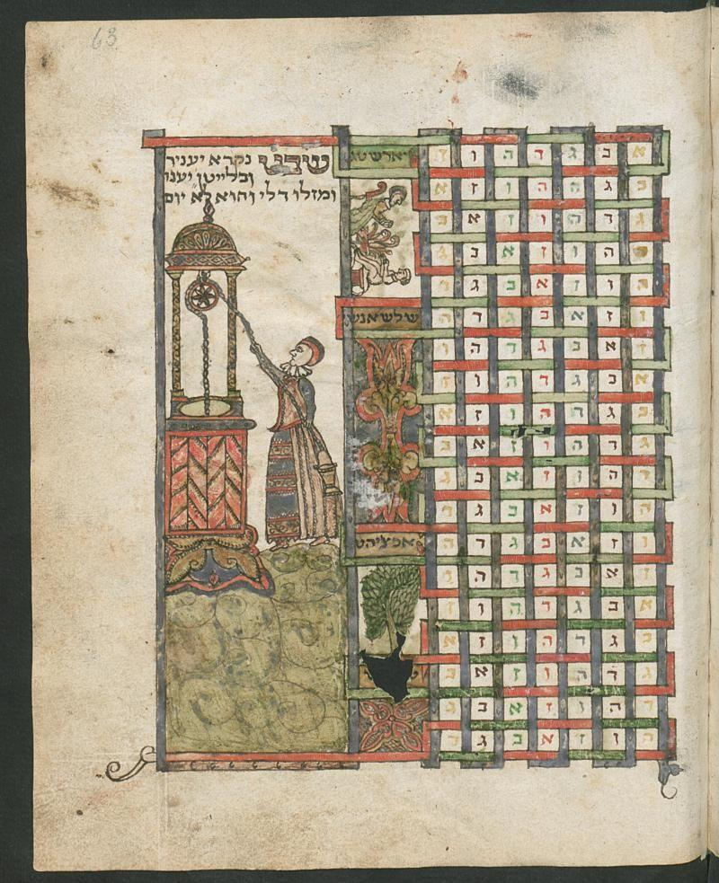
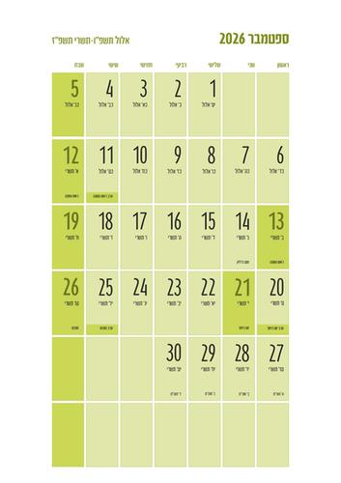
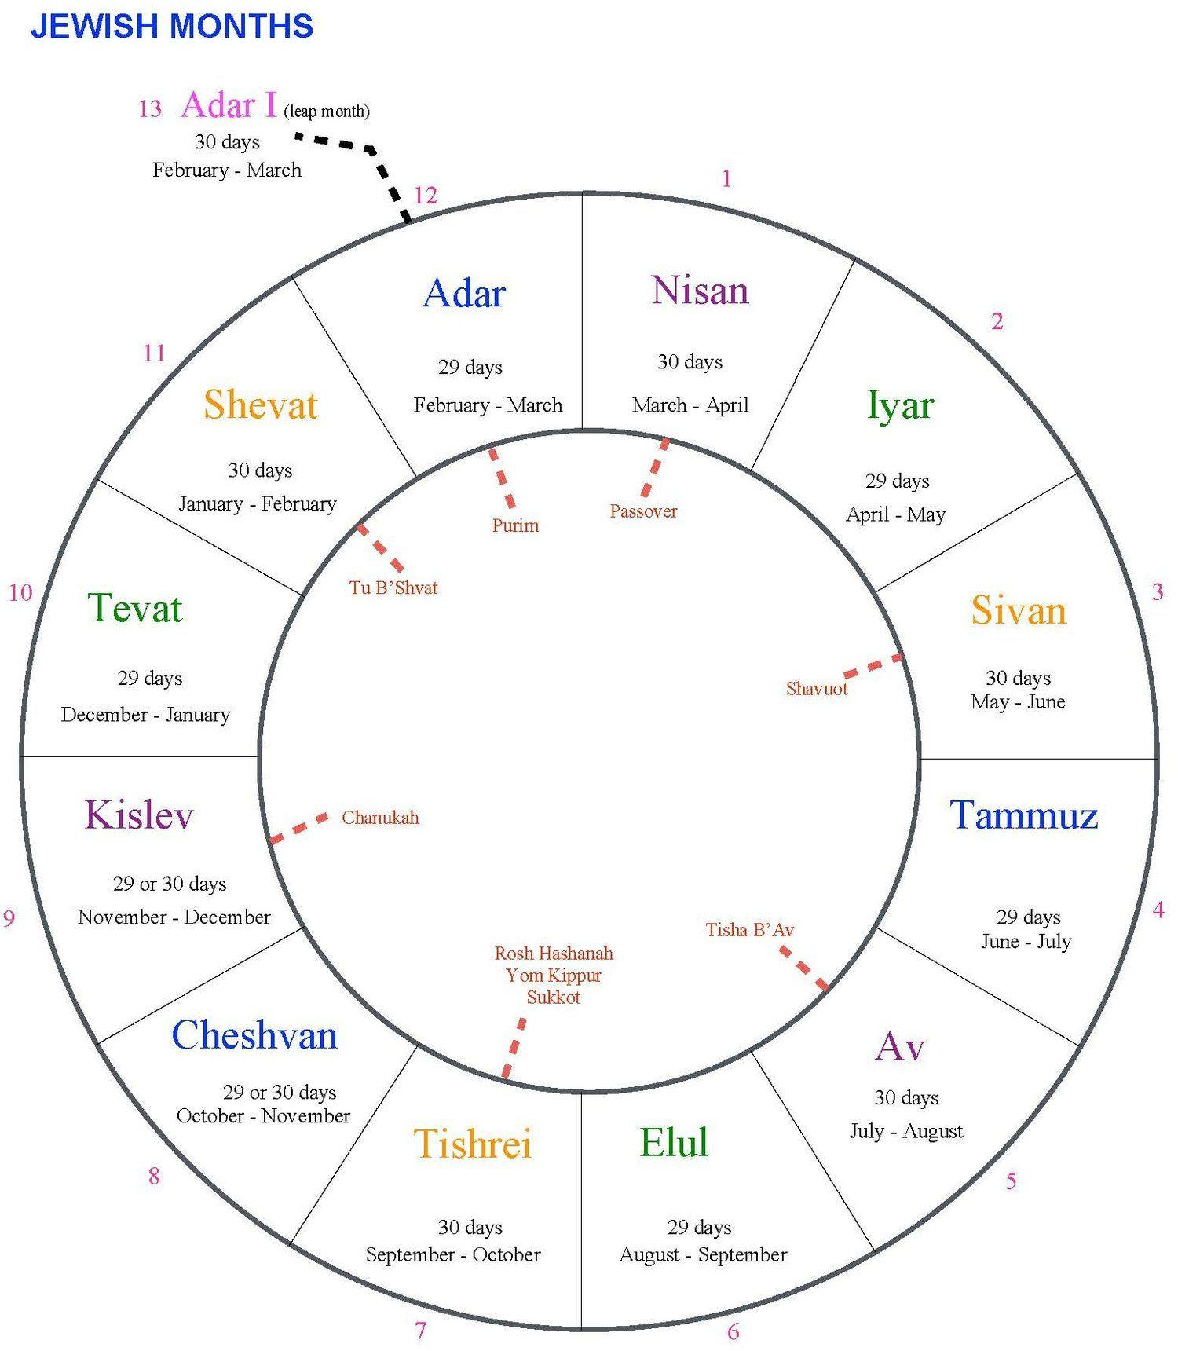
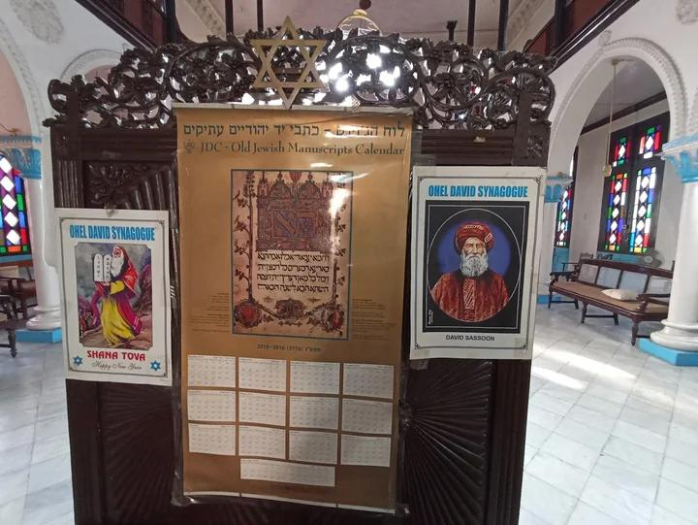
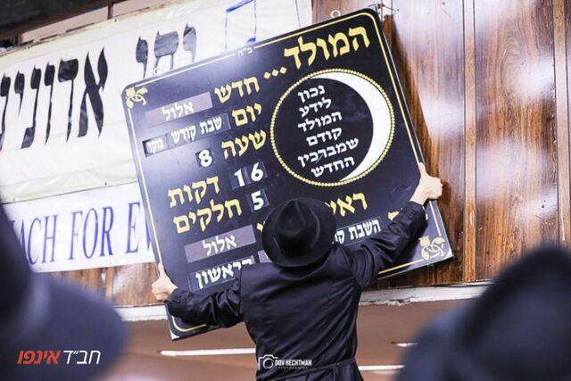
The Hebrew Calendar (also called the Jewish Calendar) is a lunisolar calendar used primarily for Jewish religious observances, festivals, and traditional events. It combines the lunar cycle (months based on the Moon) with periodic adjustments to remain synchronized with the solar year, ensuring that festivals occur in their proper seasons.
The Hebrew Calendar is one of the oldest continuously used calendar systems in the world.

Definition
# Source: AI Source: Provided by: [Data Path: Persons Table -> ID Column: 1, Name_En Column: Motasem Essam] -> From: [ChatGPT] on [7/17/2026]
The Hebrew Calendar is a lunisolar calendar consisting of 12 lunar months, with an additional leap month added in certain years to keep the calendar aligned with the solar year and the seasons.

Purpose
# Source: AI Source: Provided by: [Data Path: Persons Table -> ID Column: 1, Name_En Column: Motasem Essam] -> From: [ChatGPT] on [7/17/2026]
The Hebrew Calendar is used to:
- Determine Jewish religious festivals.
- Schedule religious observances.
- Calculate Sabbaths and holy days.
- Record traditional dates.
- Organize the Jewish liturgical year.
- Preserve seasonal alignment for religious celebrations.

History
# Source: AI Source: Provided by: [Data Path: Persons Table -> ID Column: 1, Name_En Column: Motasem Essam] -> From: [ChatGPT] on [7/17/2026]
The Hebrew Calendar has ancient origins and evolved over centuries.
Originally:
- Months were determined by observing the new Moon.
- Leap months were inserted when necessary to keep the calendar aligned with the agricultural seasons.
Today, the Hebrew Calendar is calculated using fixed mathematical rules.

Type of Calendar
# Source: AI Source: Provided by: [Data Path: Persons Table -> ID Column: 1, Name_En Column: Motasem Essam] -> From: [ChatGPT] on [7/17/2026]
The Hebrew Calendar is a:
- Lunisolar Calendar
It is based on:
- The Moon for months.
- The Sun for years and seasons.

Structure of the Hebrew Calendar
# Source: AI Source: Provided by: [Data Path: Persons Table -> ID Column: 1, Name_En Column: Motasem Essam] -> From: [ChatGPT] on [7/17/2026]
The calendar normally contains:
- 12 lunar months
- 354–355 days in a common year
In leap years it contains:
- 13 months
- 383–385 days

Months of the Hebrew Calendar
# Source: AI Source: Provided by: [Data Path: Persons Table -> ID Column: 1, Name_En Column: Motasem Essam] -> From: [ChatGPT] on [7/17/2026]
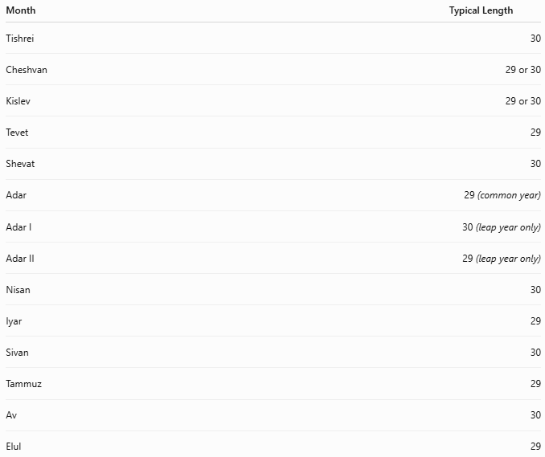
Month | Typical Length
Tishrei | 30
Cheshvan | 29 or 30
Kislev | 29 or 30
Tevet | 29
Shevat | 30
Adar | 29 (common year)
Adar I | 30 (leap year only)
Adar II | 29 (leap year only)
Nisan | 30
Iyar | 29
Sivan | 30
Tammuz | 29
Av | 30
Elul | 29

Leap Year
# Source: AI Source: Provided by: [Data Path: Persons Table -> ID Column: 1, Name_En Column: Motasem Essam] -> From: [ChatGPT] on [7/17/2026]
Unlike solar calendars that add an extra day, the Hebrew Calendar adds an entire month.
The leap month is:
- Adar I
The regular Adar becomes:
- Adar II

Leap-Year Cycle
# Source: AI Source: Provided by: [Data Path: Persons Table -> ID Column: 1, Name_En Column: Motasem Essam] -> From: [ChatGPT] on [7/17/2026]
The Hebrew Calendar follows a 19-year Metonic cycle.
Within every 19 years:
- 7 years are leap years.
- 12 years are common years.
Leap years occur in years:
3, 6, 8, 11, 14, 17, and 19 of the cycle.

Length of the Year
# Source: AI Source: Provided by: [Data Path: Persons Table -> ID Column: 1, Name_En Column: Motasem Essam] -> From: [ChatGPT] on [7/17/2026]
The length varies because of both leap months and adjustments to certain months.
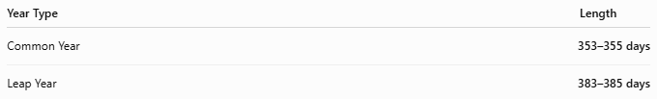
Year Type | Length
Common Year | 353–355 days
Leap Year | 383–385 days

Relationship to the Seasons
# Source: AI Source: Provided by: [Data Path: Persons Table -> ID Column: 1, Name_En Column: Motasem Essam] -> From: [ChatGPT] on [7/17/2026]
Because leap months are periodically added:
- Jewish festivals remain in approximately the same season every year.
For example:
- Passover always occurs in the Northern Hemisphere spring.

Beginning of the Year
# Source: AI Source: Provided by: [Data Path: Persons Table -> ID Column: 1, Name_En Column: Motasem Essam] -> From: [ChatGPT] on [7/17/2026]
The civil year begins with:
- Tishrei
The religious year traditionally begins with:
- Nisan
Different contexts use different starting months.

Date Format
# Source: AI Source: Provided by: [Data Path: Persons Table -> ID Column: 1, Name_En Column: Motasem Essam] -> From: [ChatGPT] on [7/17/2026]
Common Hebrew calendar formats include:
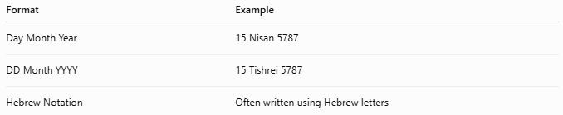
Format | Example
Day Month Year | 15 Nisan 5787
DD Month YYYY | 15 Tishrei 5787
Hebrew Notation | Often written using Hebrew letters

Major Jewish Holidays
# Source: AI Source: Provided by: [Data Path: Persons Table -> ID Column: 1, Name_En Column: Motasem Essam] -> From: [ChatGPT] on [7/17/2026]
The Hebrew Calendar determines the dates of:
- Rosh Hashanah (Jewish New Year)
- Yom Kippur
- Sukkot
- Hanukkah
- Purim
- Passover (Pesach)
- Shavuot

Applications
# Source: AI Source: Provided by: [Data Path: Persons Table -> ID Column: 1, Name_En Column: Motasem Essam] -> From: [ChatGPT] on [7/17/2026]
The Hebrew Calendar is used in:
- Synagogues
- Jewish religious communities
- Religious education
- Jewish publications
- Cultural celebrations
- Historical documentation

Advantages
# Source: AI Source: Provided by: [Data Path: Persons Table -> ID Column: 1, Name_En Column: Motasem Essam] -> From: [ChatGPT] on [7/17/2026]
The Hebrew Calendar:
- Keeps lunar months.
- Maintains seasonal consistency.
- Preserves traditional religious observances.
- Uses a mathematically predictable cycle.
- Ensures important festivals remain in their intended season.

Limitations
# Source: AI Source: Provided by: [Data Path: Persons Table -> ID Column: 1, Name_En Column: Motasem Essam] -> From: [ChatGPT] on [7/17/2026]
The Hebrew Calendar:
- Is more complex than purely solar or lunar calendars.
- Requires leap months.
- Is primarily used for religious rather than international civil purposes.
- Can be difficult for newcomers to calculate manually.

Comparison with Other Calendar Systems
# Source: AI Source: Provided by: [Data Path: Persons Table -> ID Column: 1, Name_En Column: Motasem Essam] -> From: [ChatGPT] on [7/17/2026]
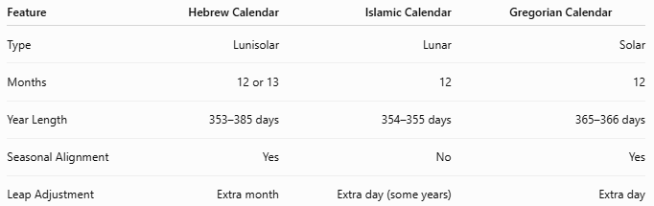
Feature | Hebrew Calendar | Islamic Calendar | Gregorian Calendar
Type | Lunisolar | Lunar | Solar
Months | 12 or 13 | 12 | 12
Year Length | 353–385 days | 354–355 days | 365–366 days
Seasonal Alignment | Yes | No | Yes
Leap Adjustment | Extra month | Extra day (some years) | Extra day

Common Mistakes
# Source: AI Source: Provided by: [Data Path: Persons Table -> ID Column: 1, Name_En Column: Motasem Essam] -> From: [ChatGPT] on [7/17/2026]
- Confusing the Hebrew Calendar with the Islamic Calendar (the Hebrew Calendar is lunisolar, while the Islamic Calendar is lunar).
- Assuming every Hebrew year has the same number of days.
- Forgetting that leap years add an entire month, not just one day.
- Assuming all months have fixed lengths.

Key Points
# Source: AI Source: Provided by: [Data Path: Persons Table -> ID Column: 1, Name_En Column: Motasem Essam] -> From: [ChatGPT] on [7/17/2026]
- The Hebrew Calendar is a lunisolar calendar.
- It combines lunar months with the solar year.
- It contains:
  - 12 months in common years.
  - 13 months in leap years.
- Leap years occur 7 times every 19 years.
- Major Jewish holidays are determined using this calendar.
- The leap-month system keeps festivals aligned with the seasons.

Conclusion
# Source: AI Source: Provided by: [Data Path: Persons Table -> ID Column: 1, Name_En Column: Motasem Essam] -> From: [ChatGPT] on [7/17/2026]
The Hebrew Calendar is a sophisticated lunisolar calendar that balances the cycles of the Moon and the Sun. By adding a leap month seven times in every 19-year cycle, it ensures that important Jewish festivals remain in their traditional seasons while preserving the rhythm of lunar months. Its combination of astronomical observation, mathematical calculation, and religious tradition has made it a central part of Jewish life and one of the oldest continuously used calendar systems in history.

